

FACULTY OF COMPUTING
SEMESTER 2 2025/2026

SECP3106
APPLICATION DEVELOPMENT
SECTION 01

LAB ASSIGNMENT 1

LECTURER: DR. AHMAD NAJMI BIN AMERHAIDER NUAR

GROUP MEMBER:
STUDENT NAME | MATRIC NO
SABRINA HENG WEI QI | A23CS0265

Table of Contents

1.0 Introduction 3
2.0 Objective 3
3.0 System Description 3
4.0 System Design and Interface Explanation 4
4.1 Activity Input Field 4
4.2 Time / Category Input Field 4
4.3 Add Button 4
4.4 Activity List Display 4
4.5 Delete Function 5
5.0 Results (Screenshots) 6
6.0 Conclusion 10

Introduction
This lab assignment in to developing a simple mobile application titled Daily Activities Recorder App by using Flutter, a popular framework that enables developers to build cross-platform applications using a single codebase. The application allows users to input, delete and display their daily activities. In this lab assignment, we have learned to apply the fundamental Flutter concepts such as widget structure, state management, project structure and user interaction.

2.0 Objective
The main objective of this lab assignment is to develop a functional mobile application using Flutter while applying basic concepts learned in the course. This assignment aims to demonstrate the use of StatefulWidget in managing dynamic data within the application. In addition, it also emphasizes the implementation of the setState() method to update user interface when changes occur. Otherwise, this assignment also need us to use TextField widgets to capture user input and ListView to display data. Lastly, the application might be designed into user-friendly interface to enhance usability.

3.0 System Description
The Daily Activities Recorder App is a basic application that enables users to record their daily activities along with a time or category.

This system allows users to:
- Enter activity name
- Enter time or category
- Add activity into a list
- View all added activities
- Delete any activity from the list
The application uses StatefulWidget to manage data dynamically. The list of activities is stored temporarily in memory and updated using the setState() function whenever changes happen.

4.0 System Design and Interface Explanation
In this application, the interface is designed to be simple, clean and easy to use by user. It consists of several key components:

4.1 Activity Input Field
The activity input field is implemented using a TextField widget, stored using String datatype. It allows users to enter name of the activity, such as Jogging or Study Python.
This field captures the main information of the activity and is required before adding it to the list. When the activity input field is not entered any information, there is a validation rules that will prompt error messages out.

4.2 Time / Category Input Field
The second input field is time or category input field. It is also implemented using a TextField widget. It is used to enter either the time or a category. For example, “8:00 PM” or “Exercise”.
This input field provides additional information for each activity recorded and it is required to fill in before adding into the list.

4.3 Add Button
The add button is implemented using an ElevatedButton widget. It is used to save the entered activity and time/category into the activity list. When the button is pressed:
- The app validates that both fields are filled
- The input values from both text fields are retrieved
- A new activity object created
- The setState() method is called to update the list
- The user interface is refreshed to display new activity.

When flow above done, the input field will be clear and allow new entries.

4.4 Activity List Display
The activity list is displayed using the ListView.builder widget. It is used to display the list of the activities entered by users in modern card design. By using the ListView.builder, it can allows efficient rendering of dynamic data.
The activity card design with the name of activity, the time or category of activity and also a delete button that able to delete the recorded activity.

4.5 Delete Function
Each activity item includes a delete button represented by an icon. When pressed:
- A confirmation popup appears asking the user to confirm deletion
- If user selected “Delete”, the selected activity is removed from the list
- The setState() method is called
- The user interface is updated accordingly
This feature allows users to manage and maintain their activity records effectively.

5.0 Results (Screenshots)
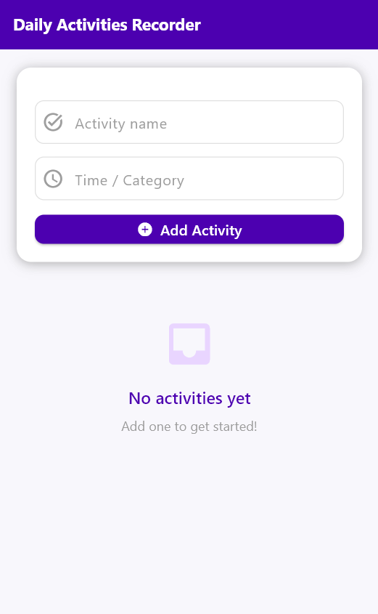
Figure 5.1: The main interface of the application (first page).

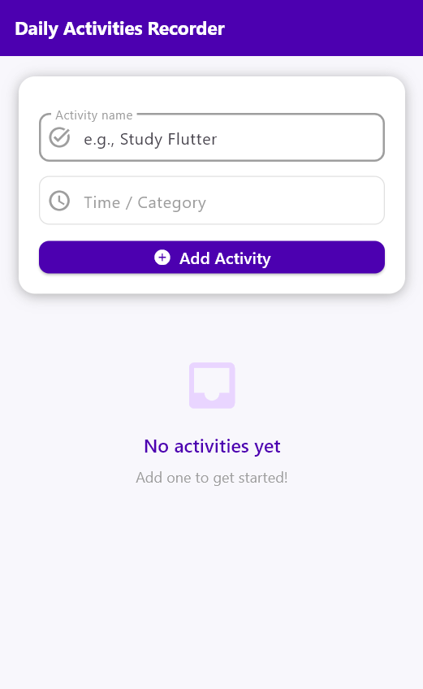
Figure 5.2: Input field with example given when toggle.

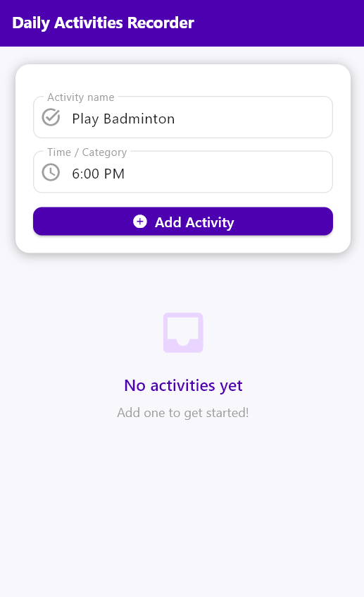
Figure 5.3: Input field with data.

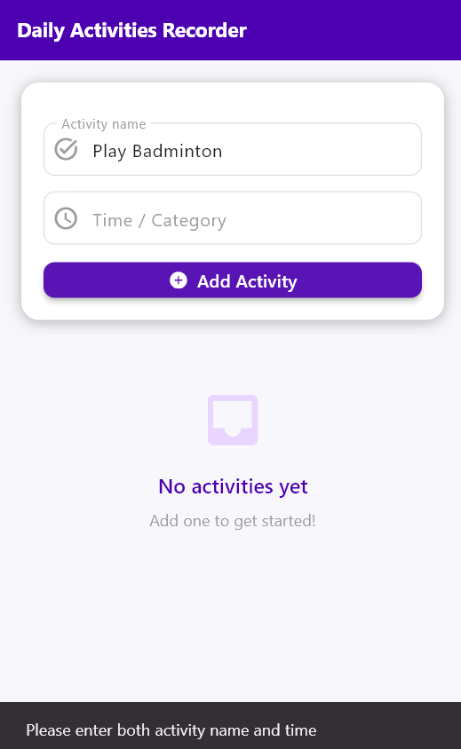
Figure 5.4: Error message pop out for input field validation.
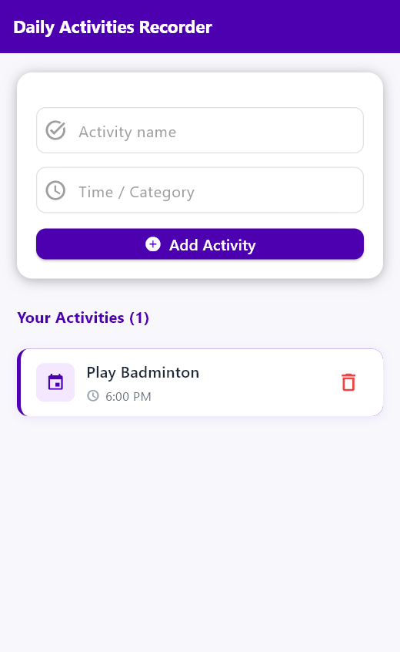
Figure 5.5: Activity displayed after added.

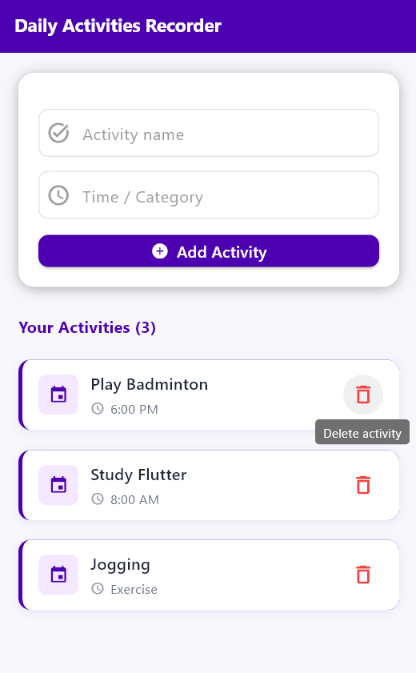
Figure 5.6: Delete button in activity list.

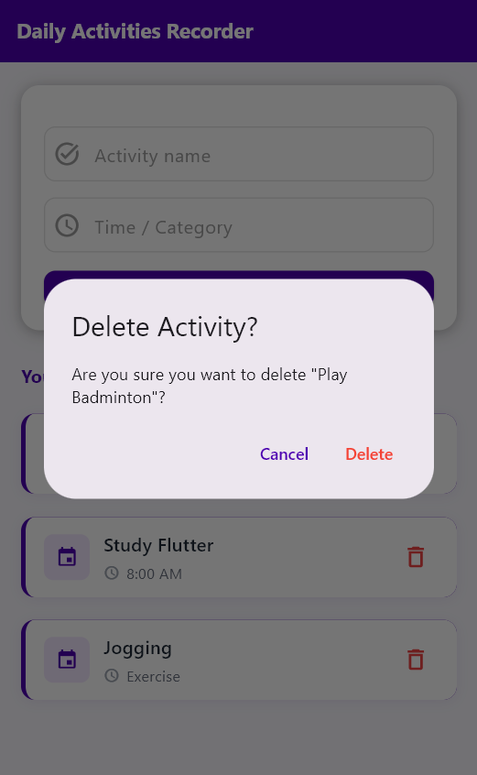
Figure 5.7: Delete confirmation pop out.

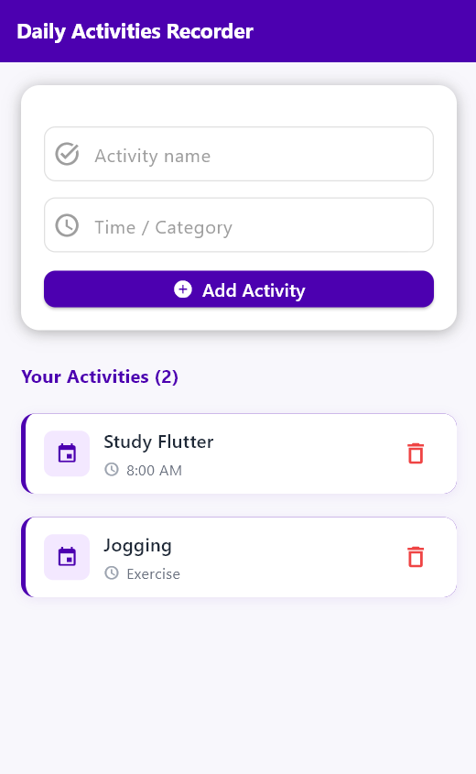
Figure 5.8: Delete activity successfully.

6.0 Conclusion
In conclusion, this assignment successfully demonstrates the basic concept of Flutter development. The application allows users to input, display and manage daily activities effectively through simple and intuitive interface.
Through the completion of this assignment, essential skills in Flutter development have been developed, including the use if widgets, state management using setState() and dynamic user interface updates. This project also enhanced understanding of handling user input and managing data within a mobile application environment.

